**CSA1195 OBJECT ORIENTED ANALYSIS AND DESIGN**

**DAY 5 LAB PRACTICAL : 12.08.2023**

**NAME : P.GUNADEESH REDDY**

**REGISTER NUMBER : 192111198**

1.Develop a system using UML for Personal Loan Management System. The admin should add new customers and view the customer's records. The admin should check the defaulters. The customer can see his/her account detail and apply for a new loan by providing the required documents, and payslip. The admin should verify the document submitted and approve the loan after verifying the payback potential of the customer.

USE CASE DIAGRAM:

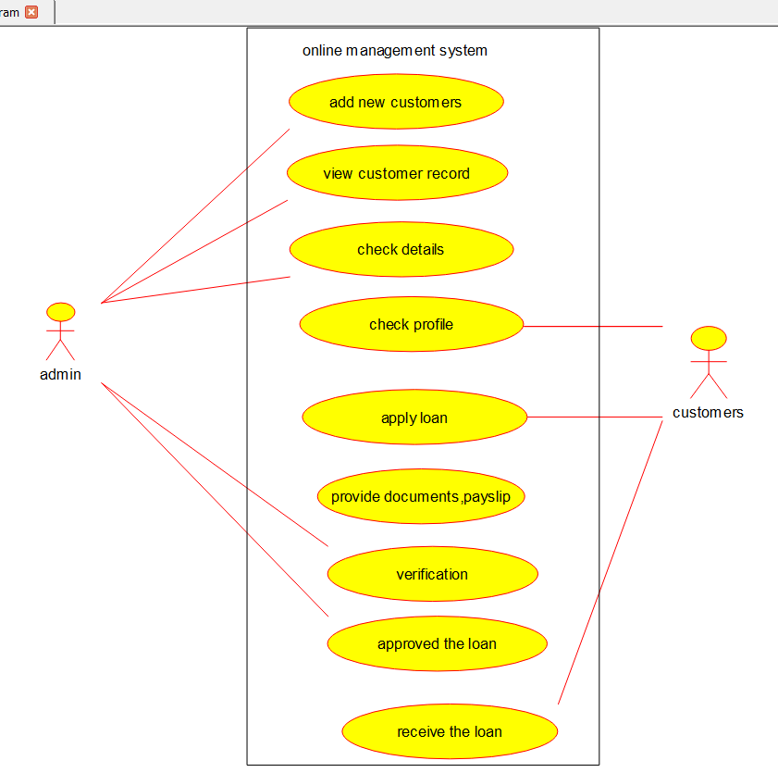

CLASS DIAGRAM:

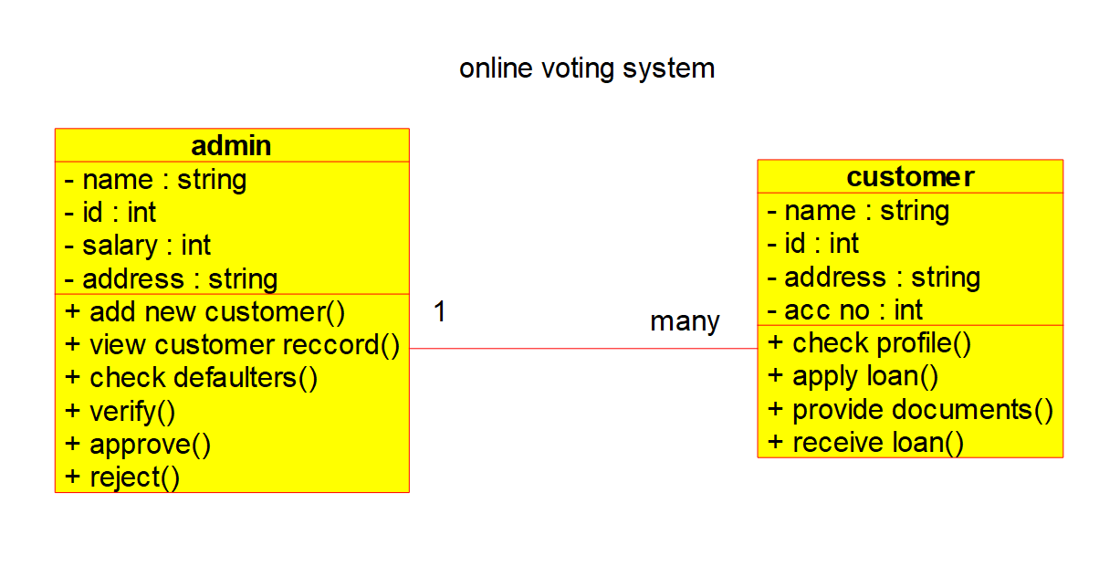

ACTIVITY DIAGRAM:

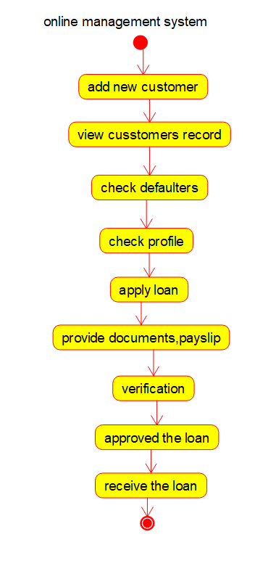

SEQUENCE DIAGRAM:

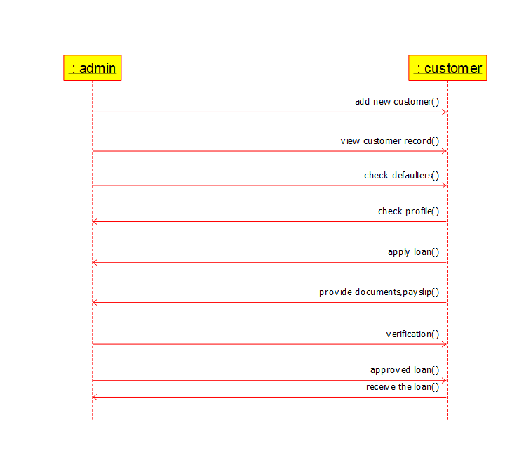

COLLABORATION DIAGRAM:

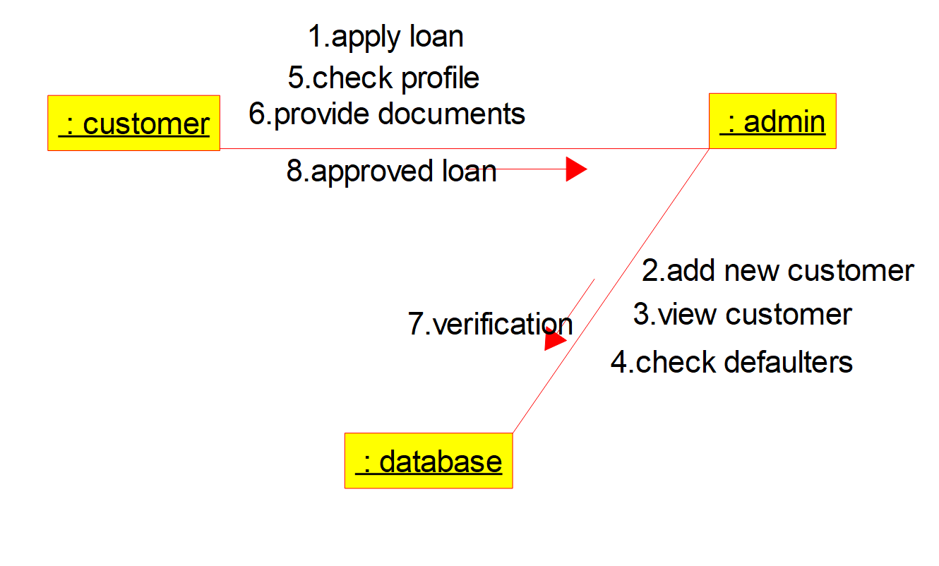

COMPONENT DIAGRAM:

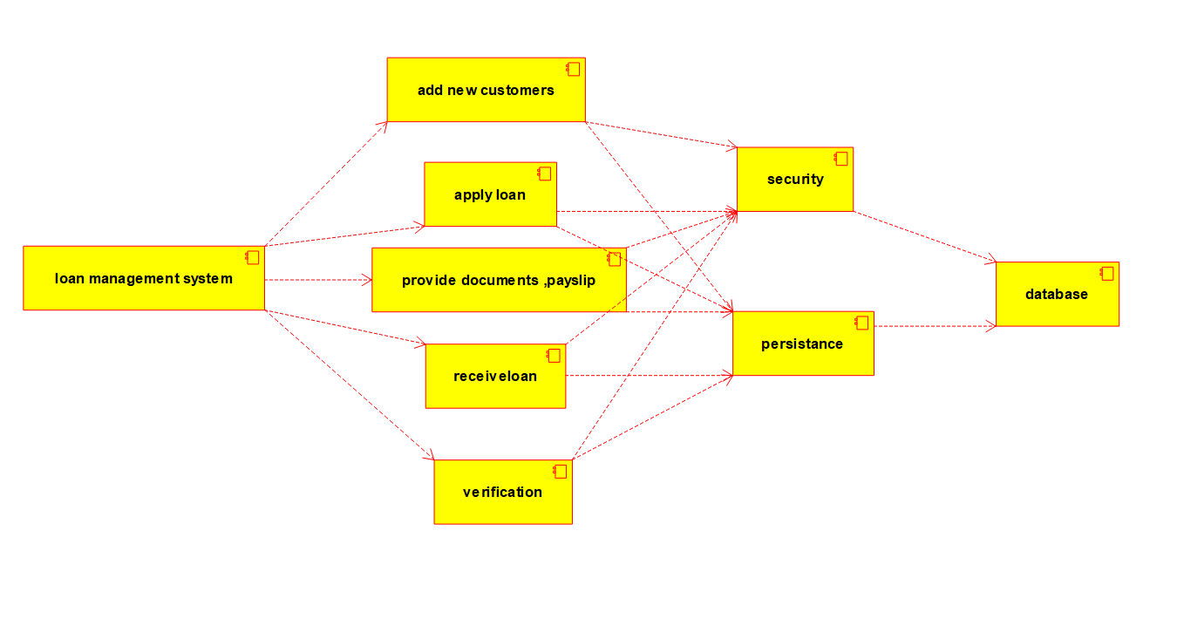

DEPLOYMENT DIAGRAM:

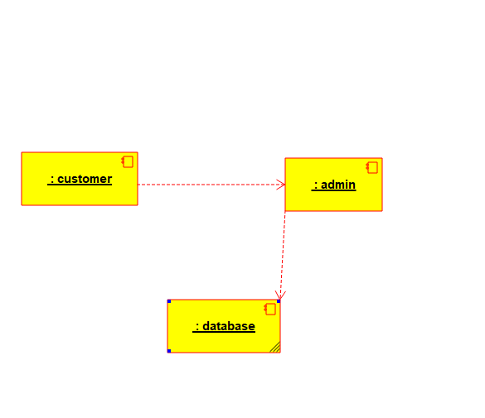

STATE DIAGRAM:

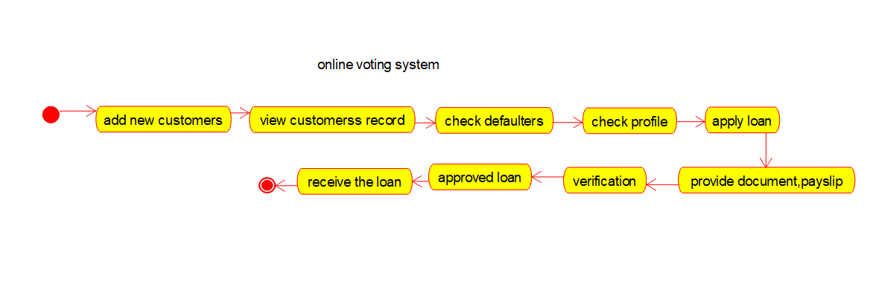

ER DIAGRAM:

